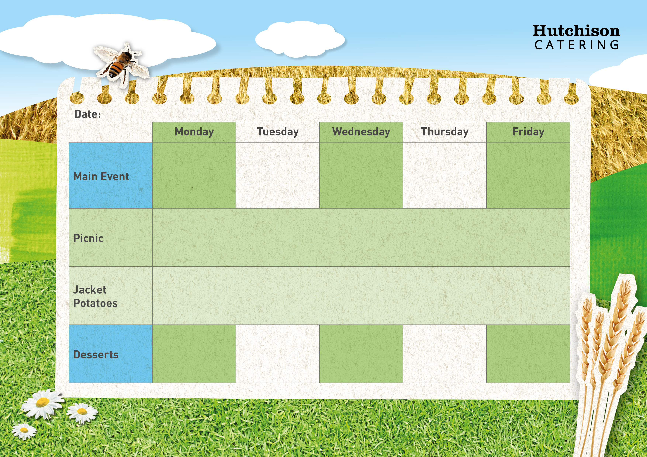

**Freshly Prepared Bread Roll or Sandwich, with Cheese, Ham, Tuna Mayonnaise or Egg Mayonnaise, Served with Mixed Salad, Healthy Snack, Dessert of the Day, or Fresh Fruit**

All Day Breakfast – Pork Sausage with Hash Brown, Baked Beans & Sliced Bread

Roast Turkey, Yorkshire Pudding with Mashed Potato, Gravy, Carrots & Garden Peas

Mexican Salsa Chicken with Rice & Broccoli Florets

**Crispy Baked Jacket Potato with Grated Cheese, Tuna Mayonnaise or Baked Beans, Mixed Salad, Dessert of the Day or**

**Fresh Fruit**

**Tadcaster - Spring Week 3 – 6/3, 27/3, 1/5, 22/5**

**Available Daily** – Fresh Bread, Water, Fresh Fruit and Yoghurt

Shortbread

Sponge Cake with Mandarins

Fruit in Jelly

Chocolate Crunch

Lemon Muffin

Crispy Battered Fish Fillet with Chips,

Garden Peas or Baked Beans

Cheese & Tomato Pizza Pinwheel with Oven Baked New Potatoes and Mixed Salad