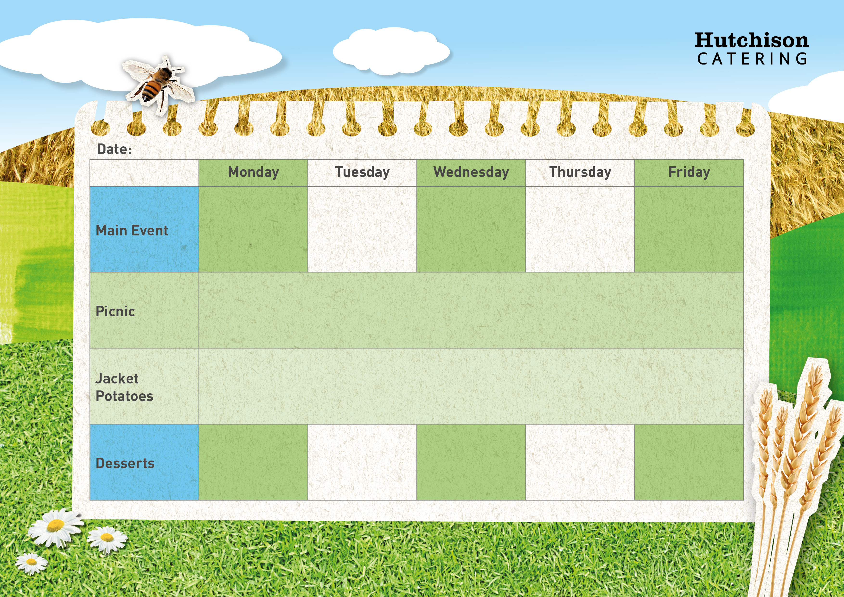

Pork Sausages with Mashed Potato, Broccoli Florets & Gravy

Roast Chicken, Yorkshire Pudding with Crispy Roast Potatoes, Gravy, Carrots & Cauliflower

Home Made Beef Bolognaise Pasta Bake with Garlic Bread & Sweetcorn

**Crispy Baked Jacket Potato with Grated Cheese, Tuna Mayonnaise or Baked Beans, Mixed Salad, Dessert of the Day or**

**Fresh Fruit**

**Freshly Prepared Bread Roll or Sandwich, with Mixed Salad, Healthy Snack, Dessert of the Day, or Fresh Fruit**

**Tadcaster - Spring Week 2 – 27/2, 20/3, 24/4, 15/5**

**Available Daily** – Fresh Bread, Water, Fresh Fruit and Yoghurt

Ice Cream Roll

Carrot Cake

Strawberry Whip with Fruit

Apple Crumble & Custard

Jam Filled Oaty Bars

Crispy Breaded Fish Fingers with Chips,

Garden Peas or Baked Beans

Margarita French Bread Pizza with Potato Wedges and Sweetcorn