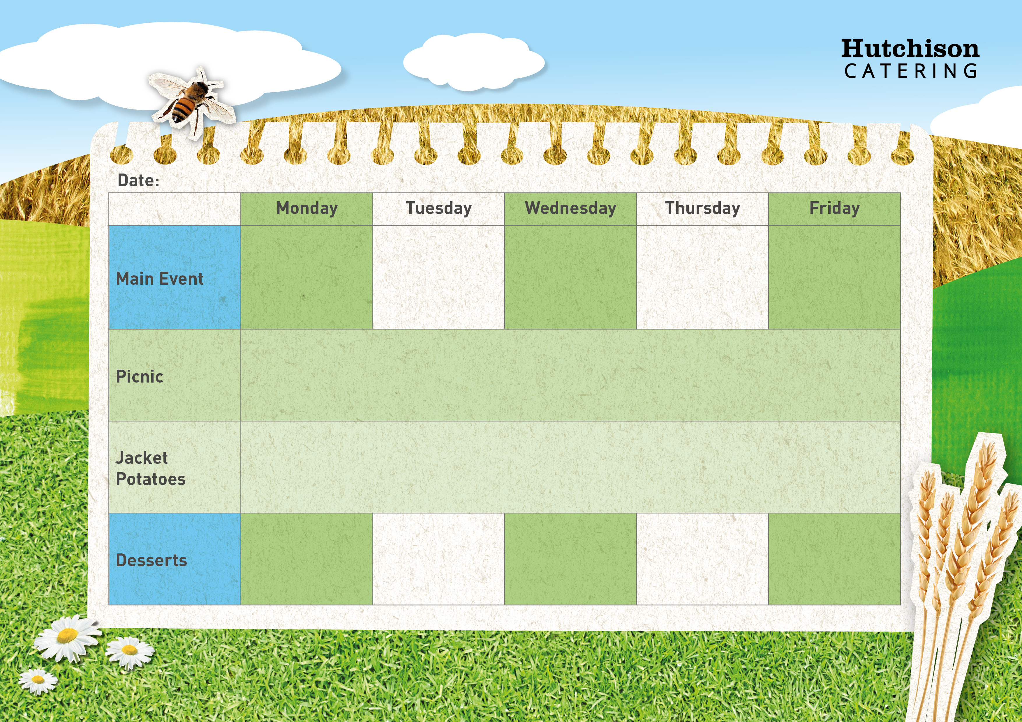

Chicken Korma with Rice, Broccoli & Naan Bread

Roast Gammon & Yorkshire Pudding with Mashed Potato, Gravy & Carrots

Beef Burger in a Soft Roll with Potato Wedges & Mixed Salad

**Crispy Baked Jacket Potato with Grated Cheese, Tuna Mayonnaise or Baked Beans, Mixed Salad, Dessert of the Day or**

**Fresh Fruit**

**Freshly Prepared Bread Roll or Sandwich, with Mixed Salad, Healthy Snack, Dessert of the Day, or Fresh Fruit**

**Tadcaster - Spring Week 1 – 20/2, 13/3, 17/4, 8/5**

**Available Daily** – Fresh Bread, Water, Fresh Fruit and Yoghurt

Fruit with Ice Cream

Chocolate Orange Biscuit

Fruit in Jelly

Banana Cake

Flapjack

Crispy Breaded Fish Fingers with Chips,

Garden Peas or Baked Beans

Home Made Cheese & Tomato Pizza with Diced Potatoes and Sweetcorn